**SEQUENCE DIAGRAM FOR BANK SYSTEM**

Diagram A: Login

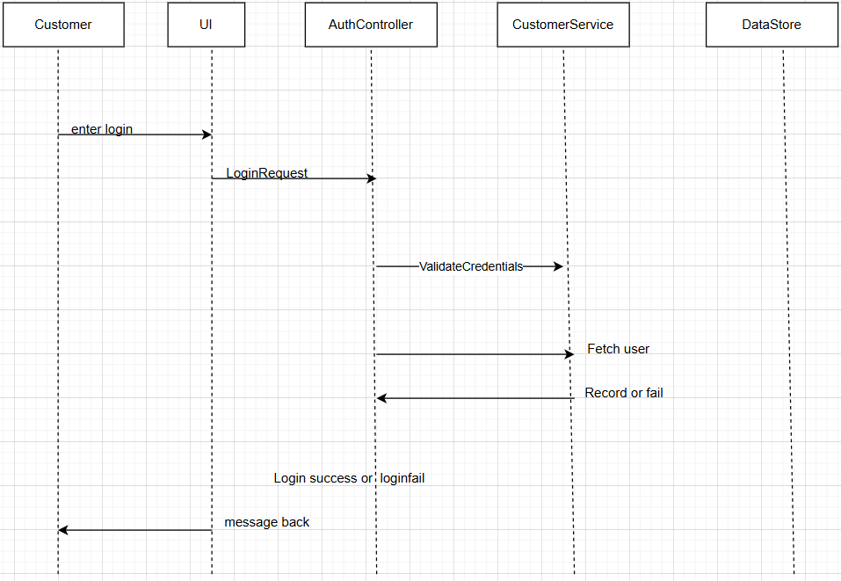

Diagram B: Deposit Funds

